**Workflow for C4C, CPQ, CPI, S4/HANA, Commissions and Success Factor**

***1. Introduction***

This document outlines the workflow for integrating Customer Relationship Management (C4C), Configure Price Quote (CPQ), CPI, S4/HANA, Commissions processes, and Success Factors. The purpose of this workflow is to streamline sales operations, enhance sales quote preparation and approval, facilitate the transfer of sales orders/contracts between CPQ and S4/HANA, and manage quotas and territories. The document provides an overview of each component's role and describes the sequential flow of activities.

***2. Components Overview***

* 2.1. C4C (Customer Relationship Management)

Cloud-based CRM system for customer interactions, sales activities, and opportunity management.

* 2.2. CPQ (Configure Price Quote)

Sales automation tool that enables sales representatives to configure products, generate accurate quotes, and handle pricing and discounting.

* 2.3. CPI (Cloud Platform Integration)

CPI facilitates integrating various systems such as C4C, CPQ, S4 Hana, and Commissions.

* 2.4. S4 HANA

S4 HANA /(ERP) integrates various business functions, including finance, sales, procurement, and supply chain management.

* 2.5. Commissions

The Commissions module will handle the calculation and management of sales commissions based on predefined rules and criteria.

* 2.6 Success Factor

SuccessFactors HXM Suite is a software application for Human Capital Management (HCM) that operates on the cloud. Offering a range of features, including but not limited to support:

* Core HR and payroll
* Talent management
* HR analytics
* Workforce planning

***3. Workflow Overview***

The workflow for C4C, CPQ, S4 HANA, and Commissions consists of the following steps:

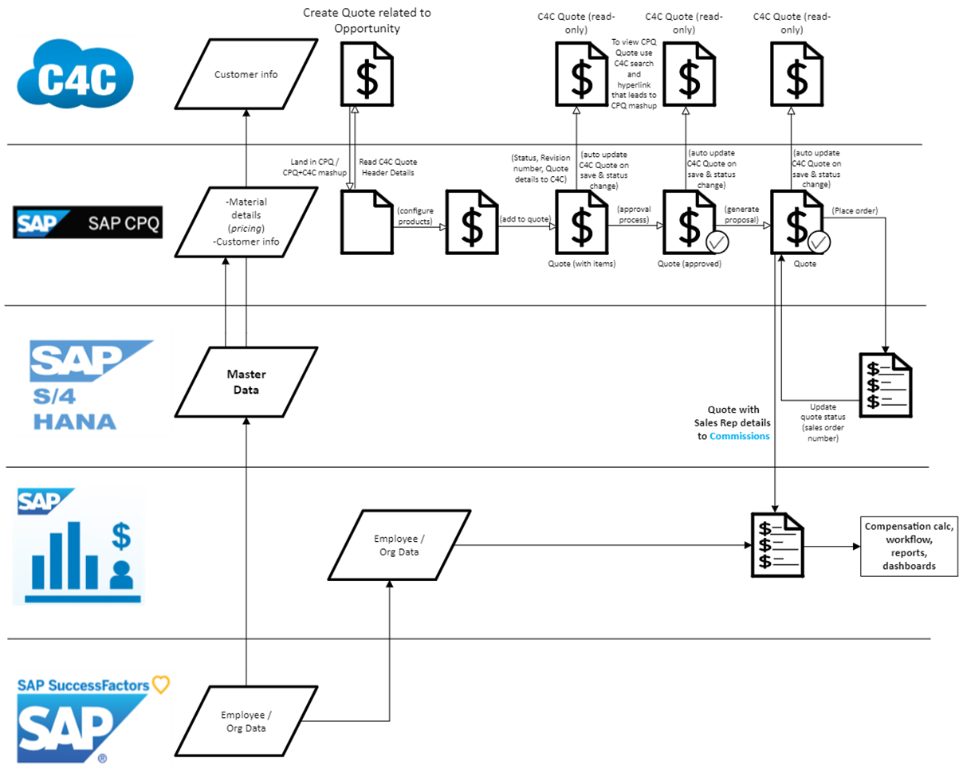

***Step 1: C4C - Sales***

* Sales representatives use the C4C CRM system to manage customer interactions, sales activities, and opportunity management.
* Leads and opportunities are created and updated within C4C.

***Step 2: CPQ - Sales Quote Preparation and Approval***

* Sales representatives utilize CPQ for product configuration and quote generation once an opportunity progresses to a quote stage.
* Sales quotes are prepared in CPQ, including the selection of products, pricing, and discounts.
* Quotes go through an approval process involving relevant stakeholders such as sales managers or finance teams.

***Step 3: CPI (Cloud Platform Integration) Workflow:***

* ***Integration Setup:*** CPI facilitates integrating various systems such as C4C, CPQ, S4 Hana, and Commissions.
* ***Data Mapping and Transformation:*** Data from different systems is mapped and transformed to ensure compatibility and seamless data flow.
* ***Data Synchronization:*** CPI synchronizes data between systems, ensuring consistency and real-time updates.
* ***Error Handling***: The system handles any data integration errors, logs them, and provides notification for resolution.

***Step 4: S4 HANA - Transfer Sales Orders/Contracts from CPQ***

* Approved quotes from CPQ are transferred to S4 HANA for further processing and fulfillment.
* Sales orders and contracts are created in S4 HANA, incorporating the details from the CPQ quote.
* Any relevant financial or logistical information is captured within S4 HANA.

***Step 5: Commissions - Quotas and Territory (Not Available Yet)***

* The Commissions module utilizes C4C, CPQ, and S4 HANA data to calculate sales commissions based on predefined rules and criteria.
* Quotas and territories are defined within the Commissions module to align sales targets and territories with sales representatives.

***Step 6: Success Factor***

* The integration with SuccessFactors facilitates synchronizing employee data and performance information.
* The sales representatives' performance data, including sales achievements, quotas, and territories, are synchronized between systems.
* This allows for accurate sales performance tracking and aligning compensation with individual and team achievements.
* Employee Control
* People Analytics
* Workforce Analytics
* Recruitment

***4. Key Deliverables and Milestones***

The following deliverables and milestones are associated with the workflow:

* Implementation of C4C CRM system with customized sales processes and opportunity management.
* Integration of CPQ system with C4C, enabling seamless quote preparation and approval.
* Integration of CPQ with S4/HANA, enabling the transfer of sales orders and contracts.
* Configuration of Commissions module with predefined commission rules, quotas, and territories.
* Testing and validating the integrated workflow to ensure data consistency and accuracy.
* Proper system connectivity and integration interfaces must be established between C4C, CPQ, S4 HANA, Commissions, and SuccessFactors.
* Data mapping and transformation rules should be defined to ensure seamless data transfer between systems.
* Security measures should be implemented to safeguard sensitive customer and employee data during integration.
* Ongoing monitoring and testing should be conducted to identify and resolve any issues or inconsistencies in the workflow.
* Establish a detailed project plan with specific timelines for each integration phase.
* Define key milestones like system configuration completion, integration testing, user acceptance testing, and deployment.

**Risks and Mitigation Strategies:**

Identify potential risks, such as data inconsistencies, integration failures, or security breaches.

Implement appropriate mitigation strategies, such as regular data validation, error handling mechanisms, and security measures.

***6. Conclusion***

The workflow outlined in this document highlights the sequential flow of activities involved in integrating C4C, CPQ, S4/HANA, Commissions, And Success Factor.

By following this workflow, organizations can streamline their sales operations, improve quote preparation and approval processes, facilitate seamless data transfer between systems, and effectively manage quotas and territories.

